ABSTRACT
Credit card fraud is a major issue for financial institutions and customers alike, as it can result in significant financial losses. Machine learning algorithms have been widely employed to detect fraudulent transactions in credit card transactions. This project presents an analysis of four popular machine learning algorithms for credit card fraud detection, including Naive Bayes, Logistic Regression, K-Nearest Neighbours (KNN), and Decision Tree. The study was conducted using a real-world credit card fraud dataset. The main objective of this study is to compare and contrast the algorithms in terms of their effectiveness in detecting fraudulent transactions. The results indicate that all four algorithms can be effectively employed for credit card fraud detection, but with varying degrees of success. This study contributes to the literature by providing insights into the effectiveness of different machine learning algorithms for credit card fraud detection.

INTRODUCTION

Credit card fraud has become an increasingly common problem in today's digital age. With the rise of online shopping and electronic payment systems, fraudsters are finding new ways to steal credit card information and make unauthorized purchases. The financial and personal impacts of credit card fraud can be devastating, making it crucial to detect and prevent fraudulent activity. In this project, we aim to use machine learning techniques to detect credit card fraud by analysing various features of credit card transactions, such as card number, CVV, expiry date, repeat retailer, used chip, used pin number, and online order history. The goal is to develop an accurate and efficient model that can detect fraudulent transactions in real-time, preventing financial losses for both the individual and the financial institution.

Machine learning has proven to be a valuable tool in detecting fraudulent activity in financial transactions. By analysing patterns and anomalies in large datasets, machine learning algorithms can identify potential fraud with high accuracy and efficiency. In this project, we will utilize four different machine learning algorithms (Naive Bayes, KNN, Logistic Regression, and Decision Tree) to develop a model that can accurately predict the likelihood of credit card fraud based on the provided features. The successful detection of credit card fraud through machine learning can help to reduce financial losses and improve the overall security of credit card transactions. Through this project, we hope to demonstrate the potential of machine learning techniques in the fight against credit card fraud.

LITERATURE SURVEY

[1] Fatima Ibrahim, Mohammed Al-Banaw, and Mohd Faizal Abdollah. Credit Card Fraud Detection: A Survey. Journal of Network and Computer Applications, 135:62-81, 2019.
Credit card fraud is a major concern for both financial institutions and customers. This project provides a comprehensive survey of credit card fraud detection techniques, covering traditional rule-based systems, anomaly detection, and machine learning approaches. The project also discusses the limitations and challenges of current fraud detection techniques and highlights potential future research directions.

[2] Amal Alphonse, Kalaivani Chellappan, and Indumathi J. Credit Card Fraud Detection using Machine Learning Techniques. Proceedings of the 2019 International Conference on Automation, Computational and Technology Management, 2019.
This project proposes a credit card fraud detection system based on machine learning techniques. The authors compare the performance of three different machine learning algorithms - Decision Tree, Random Forest, and Support Vector Machine (SVM) - and evaluate the impact of feature selection on the accuracy of the model. The experimental results show that SVM outperforms the other two algorithms, and feature selection significantly improves the performance of the model.

[3] Mridul Shukla and Kapil Sharma. Anomaly Detection Approach for Credit Card Fraud Detection. Proceedings of the 2019 International Conference on Intelligent Computing and Control Systems, 2019.
This project presents an anomaly detection approach for credit card fraud detection. The authors propose a novel feature selection technique that combines correlation-based feature selection with principal component analysis (PCA) to select the most relevant features. They then apply various anomaly detection techniques, including One-Class SVM, Local Outlier Factor (LOF), and Isolation Forest, to identify fraudulent transactions. The experimental results demonstrate that the proposed approach outperforms existing methods in terms of accuracy and false positive rate.

[4] S. Vijaya Kumar, K. Venkateswara Rao, and K. Sujatha. Credit Card Fraud Detection using Deep Learning. Proceedings of the 2019 International Conference on Communication and Electronics Systems, 2019.
This project proposes a credit card fraud detection system based on deep learning techniques. The authors use a stacked autoencoder neural network to extract features from credit card transaction data and train a classifier to distinguish between legitimate and fraudulent transactions. The experimental results demonstrate that the proposed system achieves high accuracy in detecting fraudulent transactions, with a low false positive rate.

TECHNOLOGY USED

Hardware Requirements:
- Processor: Intel i3 or higher
- RAM: 4GB or Higher
- STORAGE: 1 TB or Higher
- GPU enabled.
Software Requirements:
- Operating System: Windows 7/8/10 or Ubuntu
- Tools: Python, Anaconda Navigator, sci-kit libraries

Anaconda Navigator:

Anaconda Navigator is a desktop graphical user interface (GUI) included in Anaconda® distribution that allows you to launch applications and easily manage conda packages, environments, and channels without using command-line commands. Navigator can search for packages on Anaconda Cloud or in a local Anaconda Repository. It is available for Windows, macOS, and Linux. Navigator is an easy, point-and-click way to work with packages and environments without needing to type conda commands in a terminal window. You can use it to find the packages you want, install them in an environment, run the packages, and update them – all inside Navigator.

Sci-kit Library:
Scikit-learn(also known as sklearn) is a free software machine learning library for the Python programming language. It features various classification, regression and clustering algorithms designed to incorporate with the Python numerical and scientific libraries NumPy and SciPy. Scikit-learn integrates well with many other python libraries, such as matplotlib & plotly for plotting, numpy for array vectorization, pandas data frames, scipy.

Objectives
- With the increase in the number of fraudulent transactions, there is a need to investigate machine learning approaches that can be applied in credit card fraud detection.
- To predict credit card fraud using a systematic review of machine learning algorithms, including popular ones such as Logistic Regression, Decision Tree, Random Forest, and Artificial Neural Networks.
- Compare the performance of different ML algorithms in detecting credit card fraud and find the one with better accuracy.
- Develop a machine learning model for credit card fraud detection and integrate it into a web application using Flask for better user interface and user experience.

Methodology:
- Our aim is to predict credit card fraud detection, for prediction supervised learning is the best methodology. Supervised learning in machine learning is the most widely applied approach in many types of research, studies, and experiments, especially in predicting fraud in the financial industry. In supervised learning, the terms, attributes, and values should be reflected in all data instances. More precisely, supervised learning is a classification technique using structured training data.
- Collection of datasets form the data source, analyse the data and conduct data processing.
- Select best features that are inputs for better prediction, which can include card number, cvv, expiry date, repeat retailer, used chip, used pin number, and online order.
- Plot graphs for data visualization and analysis using matplotlib or pyplots to better understand the data.
- Train and test the dataset using various machine learning algorithms such as logistic regression, decision tree, and KNN to evaluate their performance.
- Fit the machine learning model, predict with inputs, model evaluation, and find the accuracy.
- Integrate machine learning model with a web framework like streamlit for better user interface and experience.

SYSTEM DESIGN AND ARCHITECTURE

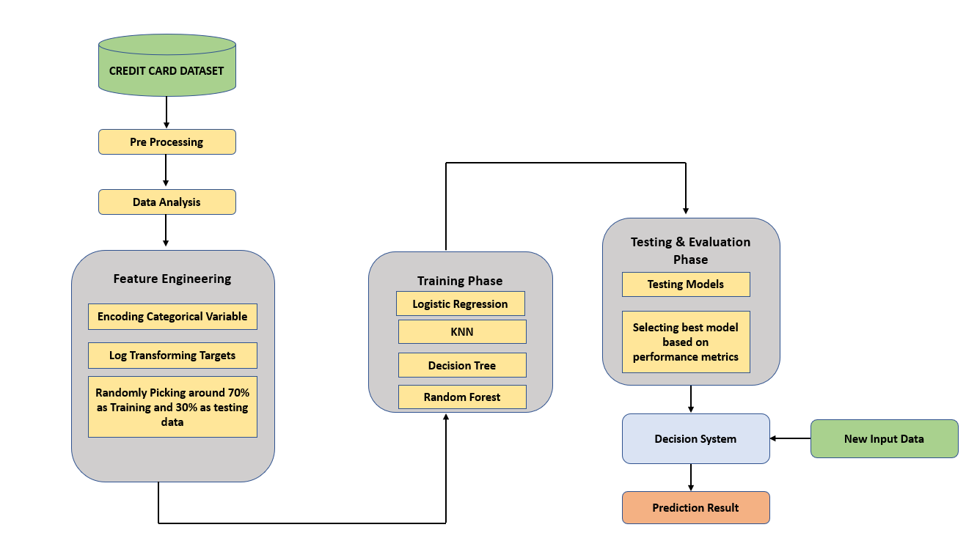
Figure: System Architecture

The objective of our study is to predict credit card fraud detection. In the process of predicting the success we are implementing four different machine learning algorithms: Logistic Regression, KNN, Decision Tree and Random Forest. We have considered some of the parameters to check the efficiency of a machine learning algorithm. The project has 6 main modules:
- Gathering data
- Preparing the data
- Choosing a model
- Training
- Prediction
- Evaluation of the model

DESCRIPTION OF THE MODULES AND ALGORITHMS

IMPLIMENTATION
We were able to determine how to differentiate between the data with the use of machine learning. While the model may not appear to be spectacular, the actions taken will define the model. This criterion may change in the future as machine learning and AI in general progress, however the steps for running the code and working are as follows:
- Gathering data
- Preparing that data
- Choosing a model
- Training
- Evaluation
- Hyper parameter tuning
- Prediction
Gathering the data
It's critical to gather trustworthy data so that your machine learning model can uncover the right trends. The accuracy of your model is determined by the quality of the data you provide the machine. If your data is faulty or old, you will get inaccurate results or predictions that are irrelevant.
Preparing the data
After the data has been obtained, the following step is to combine all of the information and randomize it. This ensures that data is dispersed evenly and that the ordering has no effect on the learning process.
- Cleaning the data to remove any undesired information, such as missing values, rows, and columns, duplicate values, and data type conversion. It's possible that you'll need to rearrange the dataset, changing the rows and columns, or the index of rows and columns.
- Visualize the data to see how it's organized and the relationships between the various variables and classes that are there.
- Creating two sets of cleansed data: a training set and a testing set. The training set is the one from which your model learns. After training, a testing set is utilised to assess the accuracy of your model.
Choosing the model
After performing a machine learning algorithm on the obtained data, a machine learning model selects the output. It is critical to select a model that is appropriate for the work at hand. Scientists and engineers have developed many models for diverse tasks such as speech recognition, image recognition, prediction, and so on. Apart from that, we must determine whether your model is suitable for numerical or categorical data and make the appropriate choice.
LOGISTIC REGRESSION
Logistic Regression is a popular supervised learning algorithm used for classification problems. It is a statistical method for analysing a dataset in which there are one or more independent variables that determine an outcome. The goal of logistic regression is to find the best fitting model to describe the relationship between the dependent variable (or response) and the independent variables (or predictors). Unlike linear regression, the response variable in logistic regression is binary or categorical.
Advantages of Logistic Regression:
- Simplicity: Logistic Regression is a simple and easy-to-understand algorithm. It is easy to implement and interpret, making it a popular choice for many classification problems.
- Speed: Logistic Regression is a fast algorithm and can handle large datasets efficiently.
- Scalability: Logistic Regression can handle both small and large datasets, making it a versatile algorithm.
- Interpretable: Logistic Regression produces coefficients for each feature that can be interpreted to determine the effect of that feature on the prediction.
- Regularization: Regularization techniques such as L1 and L2 can be used to prevent overfitting in Logistic Regression.
Disadvantages of Logistic Regression:
- Limited to linear decision boundaries: Logistic Regression assumes a linear relationship between the independent variables and the log-odds of the response variable. If the relationship is non-linear, Logistic Regression may not perform well.
- Sensitive to outliers: Logistic Regression is sensitive to outliers and can be affected by them.
- Cannot handle non-linear relationships: Logistic Regression cannot handle non-linear relationships between the independent variables and the response variable.
- Multicollinearity: Logistic Regression assumes that the independent variables are not highly correlated with each other. If the independent variables are highly correlated, it can lead to multicollinearity which can affect the performance of the algorithm.
- Binary classification only: Logistic Regression is limited to binary classification problems and cannot handle multi-class problems without modification.
NAIVE BAYES
Naive Bayes is a popular classification algorithm that is based on Bayes' theorem of probability. It is a simple, yet powerful algorithm that is widely used in text classification, spam filtering, and recommendation systems. Naive Bayes assumes that the features are independent of each other, hence the name "naive". The algorithm works by first calculating the probability of each class given a set of features. This is done using Bayes' theorem, which states that the probability of a hypothesis (in this case, the class) given the data (the features) is proportional to the probability of the data given the hypothesis, multiplied by the prior probability of the hypothesis.
Advantages of Naive Bayes:
- Simplicity: Naive Bayes is a simple algorithm that is easy to understand and implement. It does not require complex iterative algorithms like many other machine learning algorithms.
- Fast: Naive Bayes is a fast algorithm that can handle large datasets with high dimensionality.
- Performs well with small datasets: Naive Bayes requires a relatively small amount of training data to make accurate predictions.
- Handles irrelevant features: Naive Bayes can handle irrelevant features and is not affected by them.
Disadvantages of Naive Bayes:
- Assumes independence of features: Naive Bayes assumes that the features are independent of each other, which may not always be true in real-world datasets.
- Limited expressive power: Naive Bayes has limited expressive power and may not be able to capture complex relationships between features.
- Sensitive to the choice of distribution: Naive Bayes assumes a specific probability distribution for the features, which may not always be the correct choice for the dataset.
- Cannot handle continuous data: Naive Bayes is not well-suited for continuous data, as it assumes a discrete probability distribution for the features.
- Bias towards categorical features: Naive Bayes works best with categorical features and may not perform well with continuous or numerical features.
KNN
In statistics, the k-nearest neighbors algorithm (k-NN) is a non-parametric supervised learning method
In k-NN classification, the output is a class membership. An object is classified by a plurality vote of its neighbors, with the object being assigned to the class most common among its k nearest neighbors (k is a positive integer, typically small). If k = 1, then the object is simply assigned to the class of that single nearest neighbor.
k-NN is a type of classification where the function is only approximated locally and all computation is deferred until function evaluation. Since this algorithm relies on distance for classification, if the features represent different physical units or come in vastly different scales then normalizing the training data can improve its accuracy dramatically.^{[3][4]}
Both for classification and regression, a useful technique can be to assign weights to the contributions of the neighbors, so that the nearer neighbors contribute more to the average than the more distant ones. For example, a common weighting scheme consists in giving each neighbor a weight of 1/d, where d is the distance to the neighbor.^{[5]}
The neighbors are taken from a set of objects for which the class (for k-NN classification) or the object property value (for k-NN regression) is known. This can be thought of as the training set for the algorithm, though no explicit training step is required.
DECISION TREE
Decision Tree is the most powerful and popular tool for classification and prediction. A Decision tree is a flowchart-like tree structure, where each internal node denotes a test on an attribute, each branch represents an outcome of the test, and each leaf node (terminal node) holds a class label.
Construction of Decision Tree: A tree can be “learned” by splitting the source set into subsets based on an attribute value test. This process is repeated on each derived subset in a recursive manner called recursive partitioning. The recursion is completed when the subset at a node all has the same value of the target variable, or when splitting no longer adds value to the predictions. The construction of a decision tree classifier does not require any domain knowledge or parameter setting, and therefore is appropriate for exploratory knowledge discovery. Decision trees can handle high-dimensional data. In general decision tree, classifier has good accuracy. Decision tree induction is a typical inductive approach to learn knowledge on classification.

Construction of Decision Tree: A tree can be “learned” by splitting the source set into subsets based on an attribute value test. This process is repeated on each derived subset in a recursive manner called recursive partitioning. The recursion is completed when the subset at a node all has the same value of the target variable, or when splitting no longer adds value to the predictions. The construction of a decision tree classifier does not require any domain knowledge or parameter setting, and therefore is appropriate for exploratory knowledge discovery. Decision trees can handle high-dimensional data. In general decision tree, classifier has good accuracy. Decision tree induction is a typical inductive approach to learn knowledge on classification.
Decision Tree Representation: Decision trees classify instances by sorting them down the tree from the root to some leaf node, which provides the classification of the instance. An instance is classified by starting at the root node of the tree, testing the attribute specified by this node, then moving down the tree branch corresponding to the value of the attribute as shown in the above figure. This process is then repeated for the subtree rooted at the new node.

Training the model
The most crucial phase in machine learning is training. To detect patterns and generate predictions, you give the prepared data to your machine learning model during training. As a result, the model learns from the data and is able to complete the goal assigned. With practise, the model improves its ability to forecast.
Evaluation
You must evaluate your model's performance after it has been trained. This is accomplished by putting the model to the test on previously unseen data. The testing set that you split our data into before is the unseen data used. If you test on the same data that was used for training, you will not get an accurate measure because the model is already familiar with the data and recognises the same patterns. This will result in unreasonably high precision.
We receive an accurate measure of how your model will perform and its speed when you utilise it on testing data.
Tuning
Examine whether your model's accuracy can be improved in any manner once you've constructed and tested it. This is accomplished by fine-tuning the parameters in your model. The variables in the model that the programmer chooses are known as parameters. The accuracy will be the highest at a specific value of your parameter. Finding these settings is referred to as parameter tweaking.
Prediction
Finally, you can apply your model to unknown data to create accurate predictions.

SYSTEM DESIGN
Use case diagram
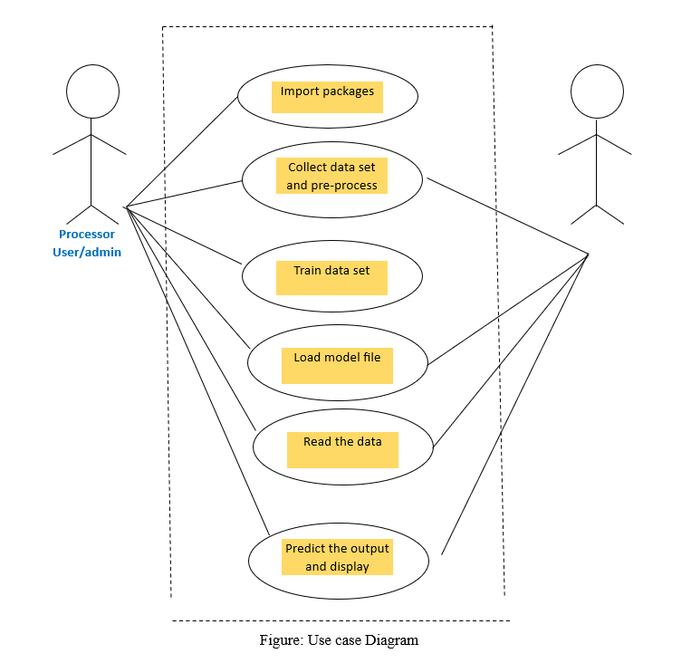
Use case consists of user and processor where user is used to provide the input to the system and processor is used to process the input data and provide output. The flow is shown in the above diagram.
First user as to run the system and run the code, model and library packages are imported and loaded. After the run of code output is displayed according to the data input provided.

SEQUENCE DIAGRAM
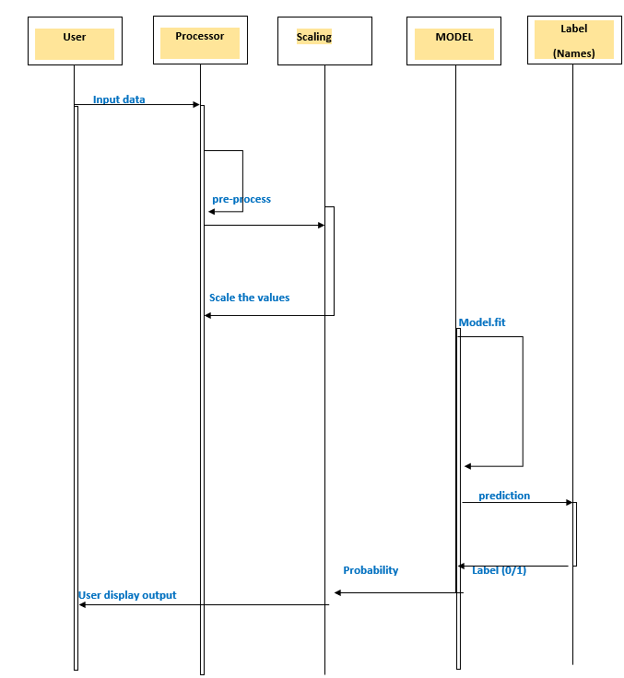
Figure: Sequence Diagram
Sequence diagram consists of 5 different blocks namely user, processor, scaling, Model and labels as shown in the above figure
User will provide the input data through the csv files already saved in the system where preprocessing of data is done which is differentiator parameters and after that those are stored in the memory unit.
After preprocessing and storing of csv is done, trained model file is loaded where the featured of the file is extracted for classifying the output. After classifying the output, Prediction values are displayed.

DATA FLOW DIAGRAM LEVEL 0
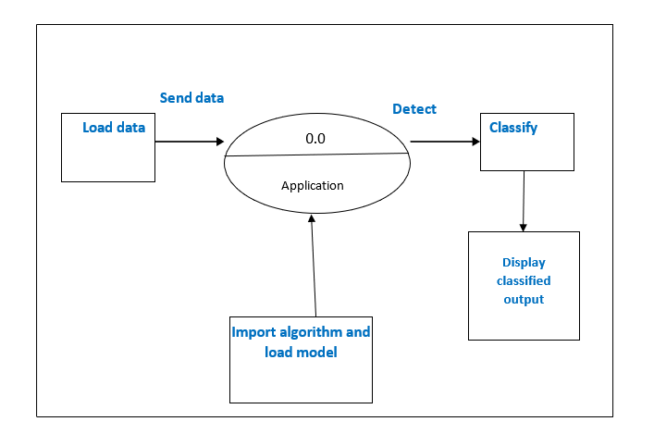
Figure: DFD 0
Above mentioned diagram is the representation of DFD0 which provides u the content diagram or say overview of the whole system. It is designed to be an at- a-glance view, showing the system as single high-level process. Here from the file data is be loaded to the application where the loaded data is sent to classification unit to predict the result with the help of trained model file and output is known.

DATAFLOW DIAGRAM LEVEL 1
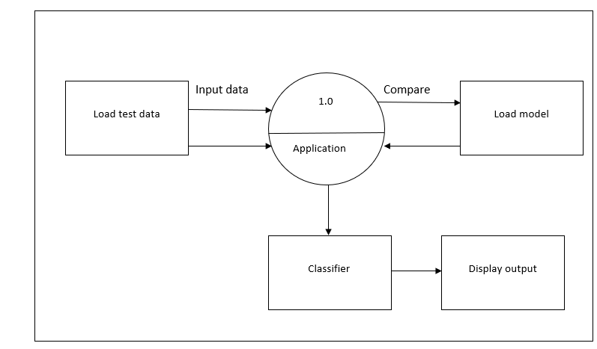
Figure: DFD 1

Above mentioned diagram is the representation of DFD1. The Level 0 DFD is broken down into more specific, Level 1 DFD. Level 1 DFD depicts basic modules in the system and flow of data among various modules. Here from the file data is be loaded to the application where the loaded data is sent to classification unit to predict the result and classes are classified given a label

Activity diagram
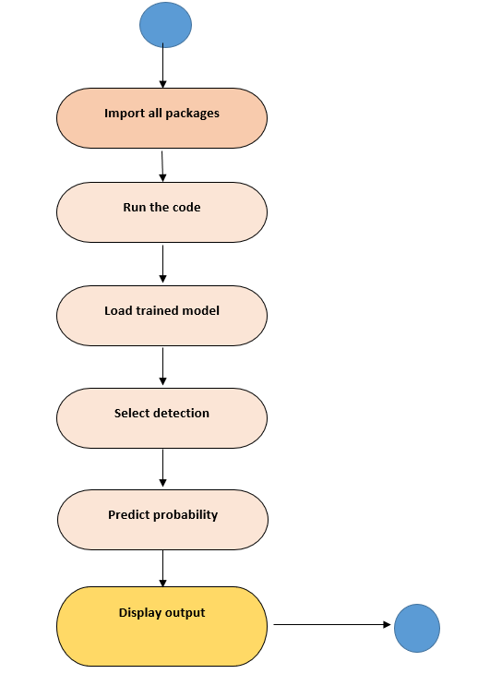
Figure: Activity Diagram

An activity diagram is a behavioral diagram i.e. it depicts the behavior of a system. An activity diagram portrays the control flow from a start point to a finish point showing the various decision paths that exist while the activity is being executed.
Firstly, we import all the library package necessary to run the code and for supporting the to code to run error free. As soon as code is run it provides the desired output

CLASS DIAGRAM
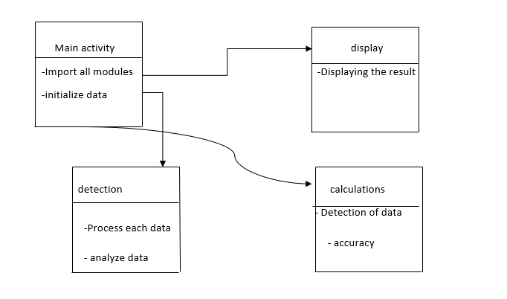

Figure: Class Diagram

The class diagram depicts a static view of an application. It represents the types of objects residing in the system and the relationships between them. A class consists of its objects, and also it may inherit from other classes. A class diagram is used to visualize, describe, document various different aspects of the system, and also construct executable software code.
It shows the attributes, classes, functions, and relationships to give an overview of the software system. It constitutes class names, attributes, and functions in a separate compartment that helps in software development. Since it is a collection of classes, interfaces, associations, collaborations, and constraints, it is termed as a structural diagram.

RESULTS

Logistic Regression:

- Classification Report
- Graphs
- Input Screenshot and Accuracy
Note: Run the project take the screenshot and add the above points

Example:
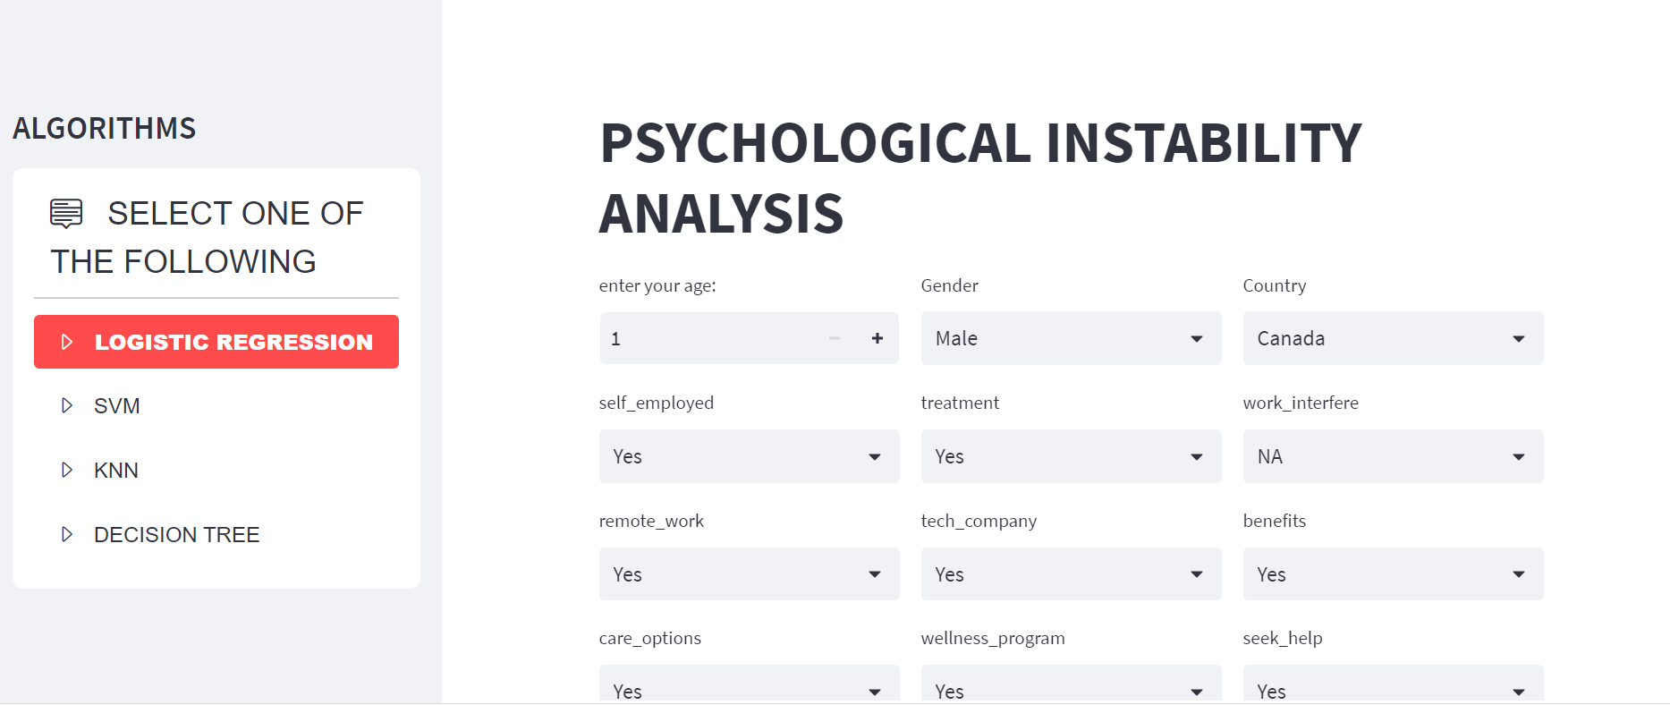

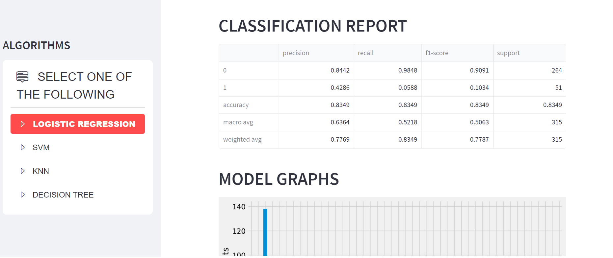

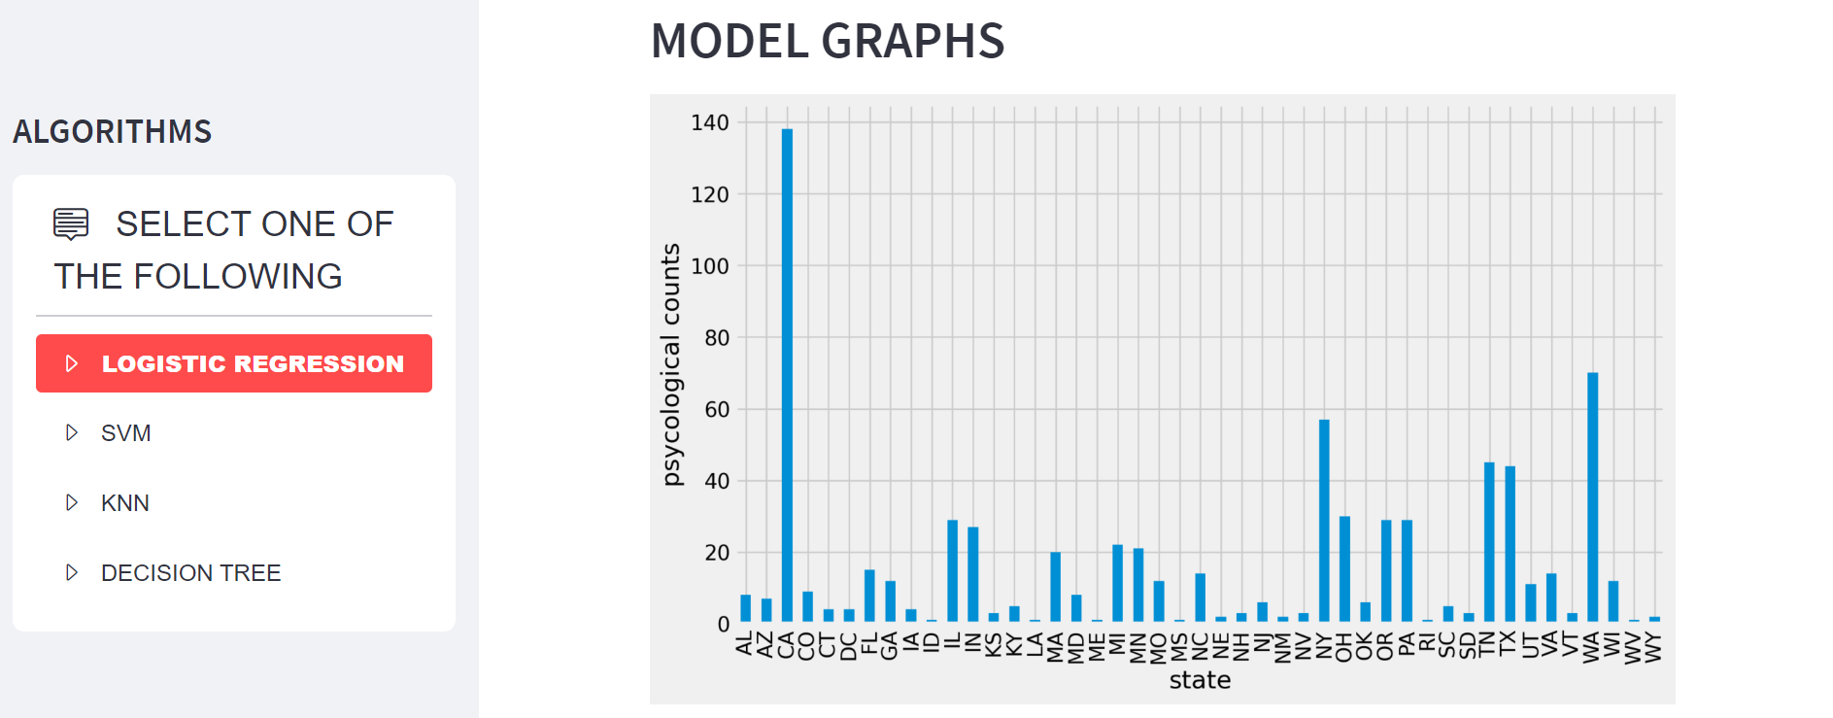

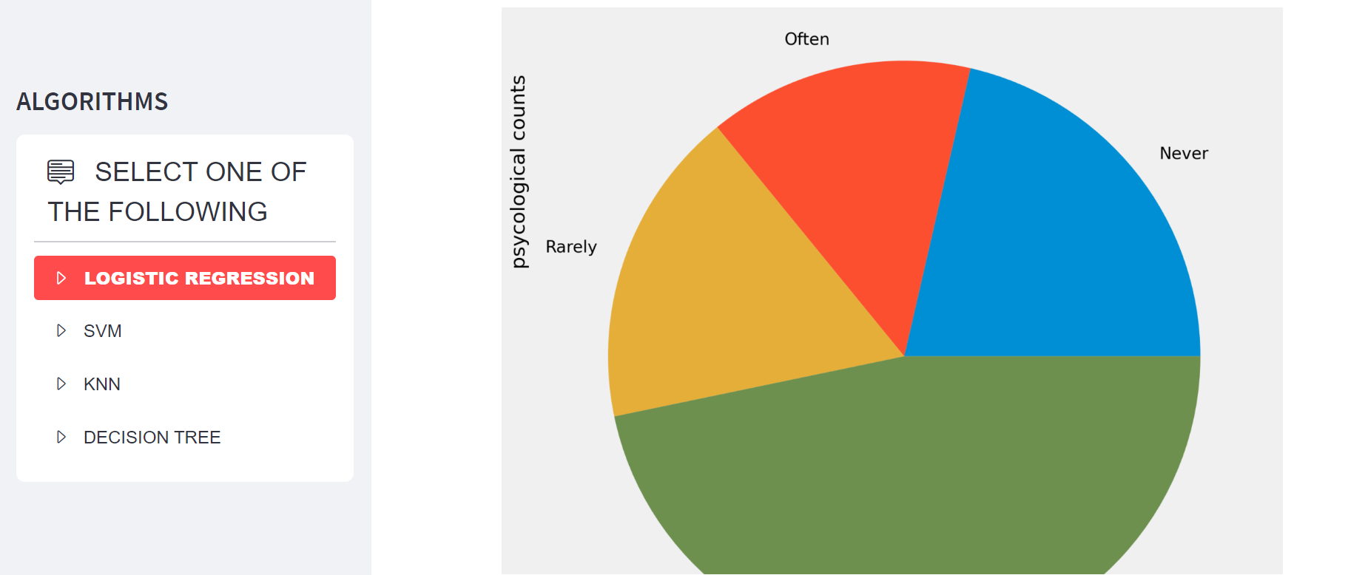

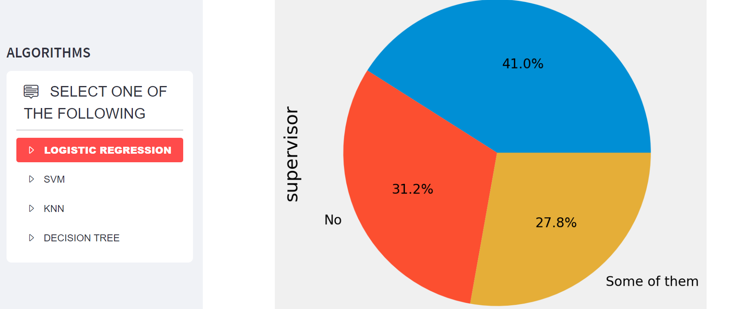

Decision Tree:

- Classification Report
- Graphs
- Input Screenshot and Accuracy
Note: Run the project take the screenshot and add the above points

KNN:

- Classification Report
- Graphs
- Input Screenshot and Accuracy
Note: Run the project take the screenshot and add the above points

Naïve Bayes

- Classification Report
- Graphs
- Input Screenshot and Accuracy
Note: Run the project take the screenshot and add the above points

CONCLUSIONS

There are various machine learning methods available for credit card fraud detection, and it is essential to assess and choose the best one for the target domain. With the advancement of machine learning and data analysis techniques, accurate detection of credit card fraud has become possible, resulting in more efficient and effective fraud prevention. In this study, we have evaluated four different machine learning algorithms to classify a dataset of credit card transactions and identify potential fraudulent activity. The results indicate that all four machine learning methods have an accuracy rate of more than average. However, it is important to note that these findings are based on a limited dataset, and further research is needed to validate the effectiveness of these methods in real-world scenarios.

REFERENCES

[1] M. A. Hasan and M. Al Hasan, "Credit Card Fraud Detection: A Meta-Learning Approach," in Proceedings of the 2018 IEEE International Conference on Data Mining Workshops (ICDMW), 2018, pp. 1462-1469.
[2] R. Bhattacharyya, D. De, S. Das, and A. K. Saha, "Credit Card Fraud Detection: A Comparative Study of Machine Learning Techniques," in Proceedings of the 2019 International Conference on Computational Intelligence and Knowledge Economy (ICCIKE), 2019, pp. 167-173.
[3] Y. Liu, J. Zhang, Y. Zhao, and Y. Liu, "Credit Card Fraud Detection Based on Machine Learning Algorithms," in Proceedings of the 2018 International Conference on Intelligent Transportation, Big Data & Smart City (ICITBS), 2018, pp. 114-118.
[4] T. Alomari, "Credit Card Fraud Detection using Machine Learning Techniques," in Proceedings of the 2018 International Conference on Advanced Science and Engineering (ICOASE), 2018, pp. 1-5.

[5] S. Dey and S. Basu, "Credit Card Fraud Detection using Machine Learning and Deep Learning Techniques," in Proceedings of the 2020 International Conference on Advances in Computing and Data Sciences (ICACDS), 2020, pp. 713-718.

